Tutorial 2

1. Find out 3 real world applications of logic gates
2. Derive the boolean expression for the following combinational logic gates

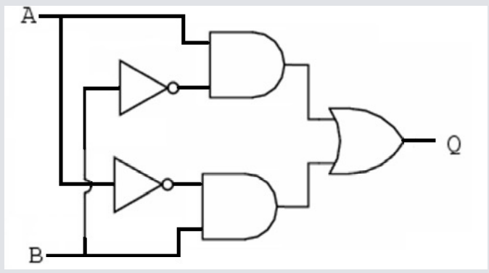

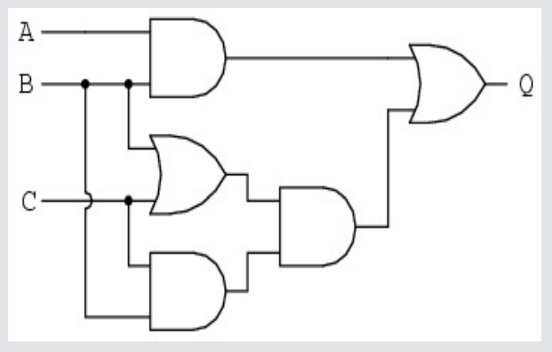

1. The diagram shows a logic circuit consisting of multiple logic gates. The table shows the output for some of the different possible combinations of inputs.

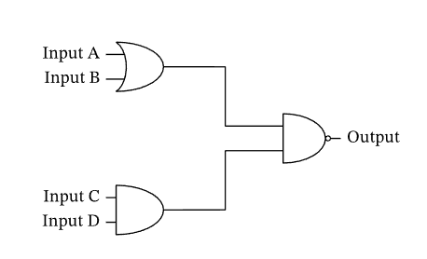

| Input A | Input B | Input C | Input D | Output |
| --- | --- | --- | --- | --- |
| 0 | 0 | 0 | 0 | 𝑝 |
| 0 | 0 | 1 | 1 | 𝑞 |
| 0 | 1 | 0 | 0 | 1 |
| 0 | 1 | 1 | 1 | 𝑟 |
| 1 | 0 | 0 | 0 | 1 |
| 1 | 0 | 1 | 1 | 𝑠 |
| 1 | 1 | 0 | 0 | 1 |
| 1 | 1 | 1 | 1 | 0 |

1. What is the value of 𝑝 in the table?
2. What is the value of 𝑞 in the table?
3. What is the value of 𝑟 in the table?
4. What is the value of 𝑠 in the table?

4. The diagram shows a logic circuit consisting of multiple logic gates. The table shows the output for some of the different possible combinations of inputs.

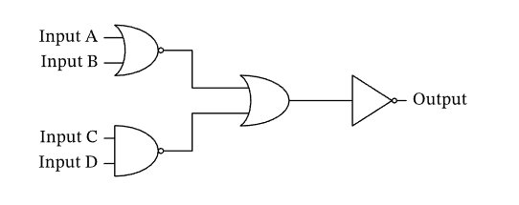

| Input A | Input B | Input C | Input D | Output |
| --- | --- | --- | --- | --- |
| 0 | 0 | 0 | 0 | 𝑝 |
| 0 | 1 | 1 | 0 | 𝑞 |
| 1 | 0 | 1 | 1 | 𝑟 |
| 1 | 1 | 0 | 1 | 𝑠 |

What is the value of 𝑝 in the table?

What is the value of 𝑞 in the table?

What is the value of 𝑟 in the table?

What is the value of 𝑠 in the table?

<https://www.nagwa.com/en/videos/536159093041/>